Chapter 8 – Genetics Lesson 3 – DNA and Genetics
The Structure of DNA
- Cells put molecules together by following a set of directions. Genes provide the directions for a cell to put together molecules that express traits, such as eye color or seed shape.
- Chromosomes are made of proteins and deoxyribonucleic acid, or DNA.
- DNA is an organism’s genetic material.
- A gene is a segment of DNA on a chromosome. Strands of DNA in a chromosome are tightly coiled, like a coiled spring. This coiling makes it possible for more genes to fit in a small space.
A Complex Molecule
- The shape of DNA is like a twisted ladder. It is called a double helix.
You can see a double helix in the figure below.
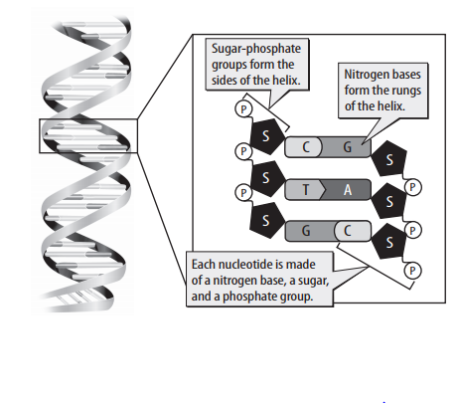
Rosalind Franklin and Maurice Wilkins used X-rays to study DNA. Some of the X-rays showed that DNA has a helix shape.
Another scientist, James Watson, saw one of the DNA X-rays. Watson worked with Francis Crick to build a model of DNA. They used information from the X-rays and chemical information about DNA discovered by another scientist, Erwin Chargaff.
Eventually, Watson and Crick were able to build a model that showed how smaller molecules of DNA bond together and form a double helix.
How DNA Replicates
- Cells contain DNA in chromosomes. So, every time a cell divides, all chromosomes must be copied for the new cell.
- The new DNA is identical to existing DNA.
- Replication is the process of copying a DNA molecule to make another DNA molecule.
- In the first part of replication, the strands separate in many places and the nitrogen bases are exposed. Nucleotides move into place and form new nitrogen base pairs. This produces two identical strands of DNA. (See diagram below).
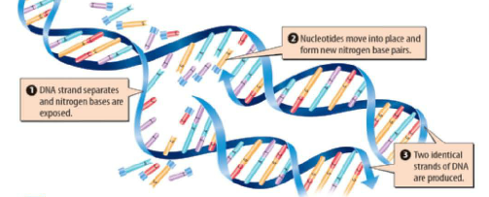
Making Proteins
Proteins are important for every cellular process. The DNA of each cell carries a complete set of genes that provides instructions for making all the proteins a cell needs. Most genes contain instructions for making proteins. Some genes contain instructions for when and how quickly proteins are made.
Junk DNA
All genes are segments of DNA on a chromosome. However, about 97 percent of DNA on human chromosomes is not part of any gene. Segments of DNA that are not parts of genes are often called junk DNA. It is not known whether junk DNA has functions that are important to cells.
The Role of RNA in Making Proteins
- Proteins are made with the help of ribonucleic acid. Ribonucleic acid (RNA) is a type of nucleic acid that carries the code for making proteins from the nucleus to the cytoplasm.
- RNA also carries amino acids around inside a cell and forms a part of ribosomes.
- RNA, like DNA, is made of nucleotides. But RNA is single-stranded, while DNA is double-stranded.
- RNA has the nitrogen base uracil (U), while DNA has thymine (T).

The first step in making a protein is to make mRNA from DNA. The process of making mRNA from DNA is called transcription. During transcription, mRNA nucleotides pair up with DNA nucleodtides. Completed mRNA can move into the cytoplasm.

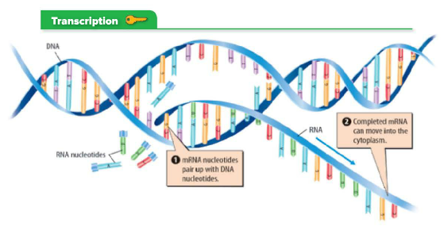

Three Types of RNA
The three types of RNA are
- messenger RNA (mRNA)
- transfer RNA (tRNA)
- ribosomal RNA (rRNA).
They work together to make proteins.

The process of making a protein from RNA is called translation. Translation, shown below, occurs as mRNA moves through a ribosome. Recall that ribosomes are cell organelles that are attached to the rough endoplasmic reticulum (rough ER).

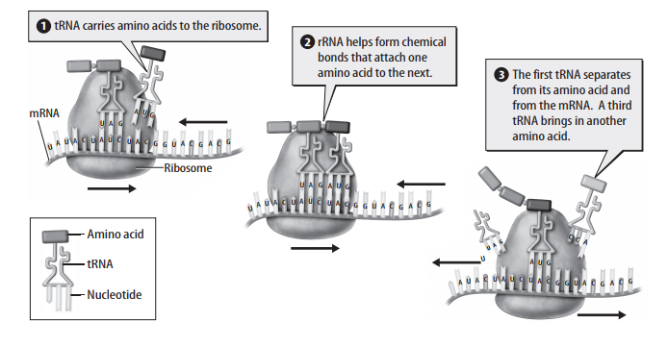
Translating the RNA Code
- Making a protein from mRNA is like using a secret code. Proteins are made of amino acids.
- The order of the nitrogen bases in mRNA determines the order of the amino acids in a protein.
- Three nitrogen bases on mRNA form the code for one amino acid.
- Each series of three nitrogen bases on mRNA is called a codon.
- There are 64 codons, but only 20 amino acids.
- Some of the codons code for the same amino acid. One of the codons codes for an amino acid that is the beginning of a protein. This codon signals that translation should start.
- Three of the codons do not code for any amino acid. Instead, they code for the end of a protein. They signal that translation should stop.
Mutations
- A change in the nucleotide sequence of a gene is called a mutation. Sometimes, mistakes happen during replication. Most mistakes are corrected before replication is finished. An uncorrected mistake can result in a mutation.
- Mutations can be caused by exposure to X-rays, ultraviolet light, radioactive materials, and some kinds of chemicals.
Types of Mutations
There are several types of DNA mutations.
- In a deletion mutation, one or more nitrogen bases are left out of the DNA sequence.
- In an insertion mutation, one or more nitrogen bases are added to the DNA.
- In a substitution mutation, one nitrogen base is replaced by a different nitrogen base.
Each type of mutation changes the sequence of nitrogen base pairs. A change can cause a mutated gene to code for a protein that is different from a normal gene.
Some mutated genes do not code for any protein. For example, a cell might lose the ability to make one of the proteins it needs.
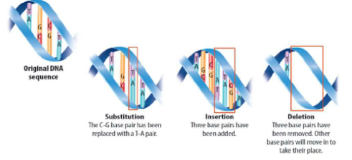
Results of a Mutation
The effects of a mutation depend on where in the DNA sequence the mutation happens and the type of mutation.
Proteins express traits. Because mutations can change proteins, they can cause traits to change. Some mutations in human DNA cause genetic disorders. With more research, scientists hope to find cures and treatments for genetic disorders.

Not all mutations have negative effects. Some mutations do not change proteins, so they do not affect traits. Other mutations can cause a trait to change in a way that benefits an organism

